18 Week Course
August 18th - December 1st, 2020
9 to 9:45am

A music & movement course for young children
Enrichment program where children can both move freely and express their voices. Our philosophy at Toddler Tuesdays is to provide a safe environment to motivate and inspire young children’s creative minds as well as their musical interests. Toddler Tuesdays is a $10 service fee and is an extension of my online nonprofit small-business, Educating Others With A Purpose (EOP). Any questions please call Austin at 858.243.8792.

Poinsettia Park
Exact meeting place to be determined
6600 Hidden Valley Rd. Carlsbad, CA 92011
Registration online at educatingwithpurpose.website
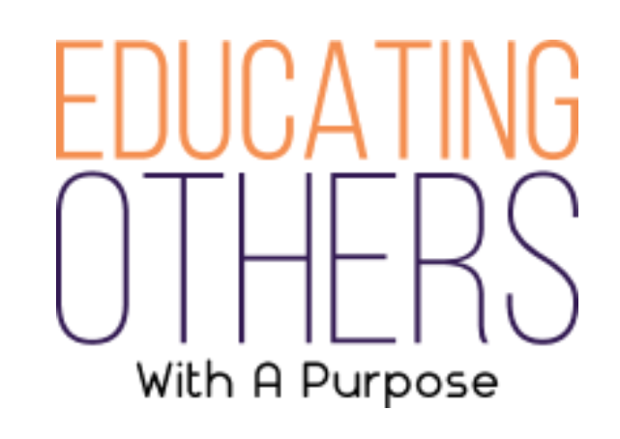

In-HomeServices And Child Care Are Provided Upon Request.

